**EXPLORING THE HETEROGENEITY** **INSIDE POPULATION**

**TO ENHANCE CROWD MODELLING OF GROUP DYNAMICS**

1. **Introduction**

Rapid urbanization and population growth are always inevitable challenges for every country in the effort of planning infrastructure, estimating traffic needs and capacities, and increasing the safety of pedestrians since over 70% of the world population is predicted to live in cities by 2050 (Weidmann, 2012). With the increase in the number of public events and the number of accidents during these events (Evers, 2011), the demand of realistic crowd simulation models becomes important for risk management in urban design and crowd safety. To make an effort for creating realistic simulation models, two approaches have been done. First approach is the studies focusing on calibration process to find realistic parameters of crowd models. Second approach is the studies trying to understand and simulate behaviours which can unfold in both normal and emergency situations such as group of pedestrians moving or competing each together.

In the second approach, various models have been proposed to simulate how pedestrians move to maintain group cohesion such as social-force based model, cellular automata model, and agent-based models. However, they either make assumption that populations are homogeneous or do not measure the impact of agent’s parameters on group behaviour. In fact, real crowds are heterogeneous. They contain pedestrians who may have different demographic traits such as age, gender in pedestrian-oriented places (e.g. school, elder-house, or sport stadium). In disasters happened such as the crush disaster at the Station Nightclub, USA in the year 2003, (Aguirre, 2011) also mentioned that a pedestrian may select a pedestrian based on these demographic traits to follow.

Group of different ped, who have different physical attributes (speed, interaction strength) different. Thus the demand of group various is indeed, and measure the effect of group behaviours

Therefore, this PhD study aims to explore the effects of group behaviours when varying group member’s parameters based on social-force model on overall evacuation, finally validate the effect of group behaviour through observation.

Propose parameter impact, parameter settings, differeniate for pedestrians types, easily apply to different pedestrian-oriented places

//contribution of study should move individually or with group in exit gate. Live-event organizer restores order of group, or move individually to enhance escape rate.

Re-order group before they transform shapes in density places

1. **Literature Review**

This section reviews significant models which simulate group dynamics, the range of models varies from modelling investigating force affecting to each pedestrian inspided by fluid dynamics, until devide cell, or define rules of follows.

**2.1. Social force model for group behaviour**

Moussaid, Helbing and colleagues (Moussaid, 2010) created the social group model based on the social-force model. The model represents that a pedestrian *p* at time *t* is trying to move with a certain desired speed $v_{p}^{d}(t)$ in a desired direction $\vec{e_{p}^{d}}(t)$ pointing from pedestrian *p*’s current position to his target position. Therefore, pedestrian *p* tends to correspondingly adapt his actual velocity ${\vec{v}}_{p}(t)$ with a certain acceleration time $τ_{p}$. The acceleration time represents pedestrian *p* changes its current velocity and return to its desired velocity. Pedestrian *p*’s acceleration at time *t* also depends on repulsive forces coming from surrounding pedestrians and obstacles. The repulsive force’s directions are represented in Figure 1. Group influence force $\vec{f_{p}^{group}}\left(t\right)$ aims to describe that an individual in group continuously adjusts its position to reduce its head direction and maintain group’s centre of mass, but also avoid group members each other as in equations. The model’s formula is represented in equations (1-3)

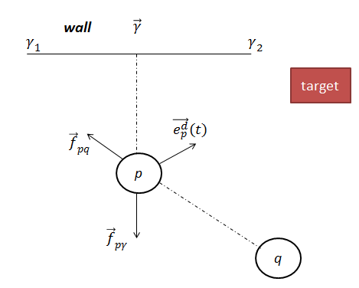

**Fig 1**. Repulsive forces ${\vec{f}}_{pq}$ and ${\vec{f}}_{pγ}$ on pedestrian *p* created by pedestrian *q* and wall γ. A group force created by pedestrian *k*

|  |  |
| --- | --- |
| $$\frac{d\vec{v_{p}}(t)}{dt}=\vec{f_{p}}\left(t\right)+ ξ_{p}(t)$$ | (1) |
| $\vec{f_{p}}(t)$ = $\frac{1}{τ_{p}}\left(v_{p}^{d}\left(t\right)\vec{e_{p}^{d}}\left(t\right)-\vec{v_{p}}\left(t\right)\right)+\sum_{q(≠p)}{{\vec{f}}_{pq}\left(t\right)+ \sum_{γ}{{\vec{f}}_{pγ}\left(t\right)+ \vec{f_{p}^{group}}\left(t\right)}}$ | (2) |
| $$\vec{f_{p}^{group}}\left(t\right)= \vec{f_{p}^{vis}}\left(t\right)+ \vec{f_{p}^{att}}\left(t\right)+ \vec{f_{p}^{rep}}\left(t\right)$$ | (3) |

where $v_{p}^{d}\left(t\right)$ is desired speed of pedestrian *p* and varies over time. Fpvis, fpatt, frep,…

//Group formation V, inverse when change parameters, b =

parameters

To summary, the social force model comprises parameters that need to be set at initial simulation time as in Table 1:

|  |  |  |
| --- | --- | --- |
| **Parameter** | **Component** | **Description** |
| $$V_{p}^{Id}$$ | Desired Acceleration | Initial desired velocity |
| $$τ_{p}$$ | Desired Acceleration | Acceleration time to reach desired speed |
| $$c$$ | Desired Acceleration | Constant to find maximum velocity |
| $$λ$$ | Interaction Force | Angular component |
| *A* | Interaction Force | Interaction strength |
| *B* | Interaction Force | Interaction range based on distance between *p*, *q* |
| U | Obstacle Force | Obstacle interaction strength |
| $${ R}_{p}$$ | Simulation | Radii of pedestrian *p* in simulation environment |
|  | Group force |  |
|  | Group force |  |
|  | Group force |  |

* 1. **Cellular Automata model for group behaviour**

CA, vizzari, and in survey. Floor field, static field, obstacle field, Formulate of group cohesion and dispersion, group formation

**2.3. Agent-based model for group behaviour**

In agent-based model, (Pelechino, 2006) constructed a simulation environment and created different pedestrian roles (leader, untrained leader, group members) through agent-based model to simulate evacuation scenarios. (Aguirre, 2011) construct a simulation environment of and compared the difference in escape numbers of several prototypes constructed on agent-based model. The prototypes include individual behaviour, intermediate group (revert to individual behaviour while in duress), full group behaviour (follow group leader). The escape numbers are compared with actual survivor number. On social aspect, the author mentioned that a group leader can be selected by other through demographic traits such as age, gender and familiarity with environment. A group member follows leader if they are in the leader’s line of sight.

Another study to see group formation

1. **Research Questions**

Group always move through statistic , “” quote of some one famous… Since in both of normal and evacuation, pedestrian could be varies different ped type,. Moussad through observation found that (V, breast, …) ,auto form to minimize in high-densed places. To measure the group behaviour, cohesion degree proposed as… .Group behaviour can formulated by group cohesion degree equation (), and group formation (different order)

To simulate group cohesion behaviour, force-based model and cellular automata model make assumption that populations are homogeneous and well-mixed, which is not true for real population at different pedestrian-oriented places (e.g sport stadium, high schools, working places) in recent studies (Leeson, 2014) and another Naturetechnical report (Gosce, 2014). It is also explained that the earliest models including Reynold’s model (Reynolds,1987) and Social Force model (Helbing & Molnar,1995) averaged out potential influences to produce smooth flow of pedestrian movement (Collin, 2014). In studies using agent-based model approach, one of the clearest limitations mentioned in the future work of the study (Weijmen, 2013) is the lack of a standard mechanism to measure the effects of agent’s parameters in the pedestrian’s force calculation.

Hoordegedonn found that, different ages behave different, and have different parameter distribution. Move irraotionally unwanted to maintain group cohesion; thus, become obstacles for other pedestrians .Same size, if ped has diff value pamarame, different cohsion value, format.

This study only uses social-force models since it is higly recommend by Hoorgedon 2013 for simulating obstacle crowd phenomena… (). And various rules. Therefore, this study proposes follow questions to analyse the effect group behaviour when vary parameters of different agents in social force model and how it impact on escape rate:

1. What is the effect of social-force model’s parameters in group behaviour when simulating group of different members?

1.1.How to simulate different agents having different parameter distributions in social-force model?

1.2.Is group cohesion degree different when vary parameter of each pedestrian?

1.3. Is group formation different when vary social-force of each pedestrian?

* 1. How group behaviour affect escape rate when varying values of each pedestrian?
  + Does group generates different formation?
  + Does it generate allow when interact with another group individually, split o group cohesion, dispersion?

1. How to validate that effect through real observation?
2. **Research methodology**

The questions can be formulated as Figure

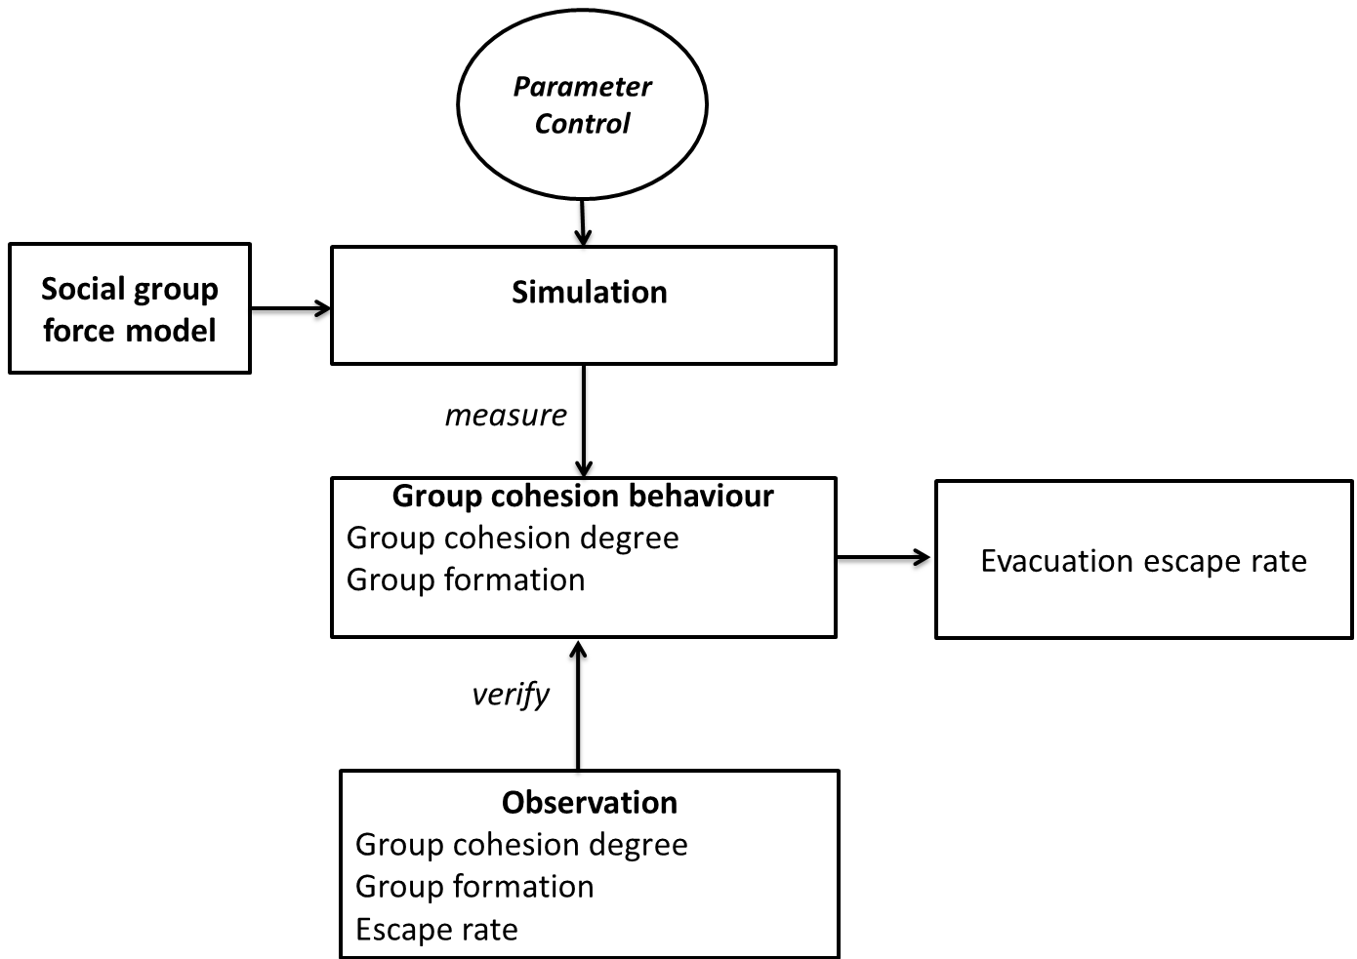

Recent, hoogedone found that equation (parameters less than) hypothesis: children > adult> elder velocity or low parameters, same group size, same percentiage of pedestrian inside crowd.

Is the difference in using same distribution for 3 members types, or different member types.

Developing this tool will allow us to easily customize initial parameters of each pedestrian and environment, and monitor expected information from crowd. Investigating what causes the difference in escape rate and blockage occurrences is then performed respectively on one and two dimensional simulations with simplified versions of social force model. It aims to understand the impact of possible reasons (e.g. parameter distribution, placements, velocities of pedestrians during simulation duration before phenomena occur).

p-children, different equation,

p-adult, different equation,

p=elderly, different equation,

Look at the relationship between group cohesion, and group dispersion degree? Group cohesion degree when various this parameter, t-test between centroid of this results when varying this parameter set of each group member type.

Look at possible group formation generate this difference from this parameter set?

Vary parameters for each pedestrian values.

Apply t-test and measure blockage, frequency, …

Show the format of N! depend on pedestrians,

Apply each parameter, generate for other as Helbing suggestion (Helbing, 2014). Generate Evoluton nary to measure escape rate, group cohesion degree.

Beta same, group cohesion same, escape rate different, (simulation then drag to stop and swap position to see the difference).

Q.2. How to verify this difference in escape rate by actual data?

Two groups are invited and move, a camera

Experiment 1: 9ped move individually

Experiment 1: same size, 9 pedestrians in gate floor 6, not interact with other group

Change percentage: well-mixed (30,30,30), dominant of each pedestrian type, move individually

Hypothesis: move individually faster, children move faster, adult, elderly. Kknow background, and how they order to escape

Experiment 2: interact with another crow people move individually, who move individually.

Compare escape rate with case study1.

**Table 1**- Data acquisition of group member and group information to infer group cohesion

|  |  |
| --- | --- |
| **Scope level** | **Acquired Data** |
| Group (meso level) | Percentage of pedestrian types in group  Total population size  Average speed at a certain time  Centre point of mass at a certain time |
| Individual (micro level) | Pedestrian type through hat colour  Pedestrian trajectory  Distance to other group members at a certain time  Distance to group’s centre of mass  Average speed over the time |
| Overal evacuation | Escape rate |

Table 1 represents required data to understand the effect of group cohesion towards different pedestrian inside group and other groups.

1. **Research progress**

Research simulation, blockage frequency

Research time line

1. **Coursework and professional development**

As required from our faculty, I completed the course FIT 5143 in the first semester 2015. I am attending the course FIT6021 from 31 July, 2015. I also completed 116 research training hours as in Table 3.

**Table 5**- List of professional development undertaken

|  |  |
| --- | --- |
| **Activity** | **Hours counted towards coursework goal** |
| Faculty Induction | 4 |
| Research Integrity | 12 |
| FIT 5143 Course | 48 |
| FIT 6021 |  |
| FIT 4012 | 15 |
| Monash Seminar/workshop attendance | 22 |
| Participation at Monash Bootcamp Commercialisation workshop in the year 2015 | 15 |

1. **References**

Aguirre, B. E., El-Tawil, S., Best, E., Gill, K., Fedorov, V., (2011) Contributions of social science agent-based models of building evacuation. *Contemporary Social Science: Journal of the Academy of Social Science*, Pages 415-432.

Almeida J. E., Rosaldo, R., Coelho, A. L., (2011) Crowd Simulation Modelling Applied to Emergency and Evacuation Simulations using Multi-Agent Systems. *In Proceedings of 6th Doctoral Symposium on Informatics Engineering*, DSIE.

Daamen, W., & Hoogendoorn, S. P.,2012. Calibration of pedestrian simulation model for emergency doors for different pedestrian types. *Transportation Research Record*, 2316, 69 - 75.

Evers, J. (2011) Modelling Crowd Dynamics: a Multiscale, Measure-theoretical Approach. *Master Thesis*. Eindhoven University of Technology, The Netherlands.

Gosce, L., Barton, D. A. W., Johansson, A., (2014) Analytical Modelling of the Spread of Disease in Confined and Crowded Spaces, *Nature Scientific Reports*, Vol. 4(4856).

Grosshandler, W., Bryner, N., Madrzykowski, Kuntz, K., (2005). Report of the Technical Investigation of the Station Nightclub fire. Technical report, *National Institute of Standards and Technology, USA*, 2005. Available at <http://fire.nist.gov/bfrlpubs/fire05/PDF/f05032.pdf>

Hoogendoorn, S.P., Duive, .D.C., Daamen, W., (December 2013). State-of-the-art crowd motion simulation models. *Transportation research part C*, Volume 37, Pages 193-209.

Hoogendoorn, S.P., Bovy, P. H.L (2003) Simulation of pedestrian flows by optimal control and differential games. *Optimal Control Applications and Methods*, Volume 24, Pages 153-172.

Helbing, D., Molnar, P., (1995) Social force model for pedestrian dynamics. *Physical Review E,* 51.

Helbing, D., Farkas, I., Vicsek, T., (2000). Simulating dynamical features of escape panic. *Nature*, Pages 4487-4490

Helbing, D., Balietti, S., (2011). How to Do Agent-Based Simulations in the Future: From Modeling Social Mechnisms to Emergent Phenomena and Interactive Systems Design.

Helbing, D., Mukerji, P., (2012). Crowd disaster as systemic Failures: Analysis of the Love Parade Disaster. *EPJ Data Science*, Volume 1(7).

Helbing, D., Brockmann, D., Chadefaux, T., Donnay, K., Blanke, U., Meza, O. W., Moussaid, M., Hohansson, A., Krause, J., Schutte, S., Perc, M., (2015) Journal of Statistical Physics, Vol. 158(3), pp 735-781.

Moussaid, M., Helbing, D., Garnier, S., Johansson, A., Combe, M., Theraulaz, G., (2009) Experimental study of the behavioural mechanism underlying self-organization in human crowds. *The proceeding of The royal society part B*.

Moussaid, M., Perozo, N., Garnier, S., Helbing, D., Theraulaz, G., (2010) The Walking Behaviour of Pedestrian Social Groups and Its Impacts on Crowd Dynamics. Plos One, Vol 5(4)

Moussaid, M., Theraulaz, G., (2012). Traffic Instabilities in Self-Organized Pedestrian Crowds. *PLos Computational Biology*.

Pelechano, 2006. Crowd Simulation Incorporating Agent Psychological Models, Roles and Communication. *In proceeding of 1st Workshop of Crowd Simulation*.

Reynolds, C., W., (1987), Flocks, herds and schools: A distributed behavioural model, New York, *NY: ACM*, 25-34.

Seer, S., Rudloff, C., Matyus, T., BBrandle, N., (2014). Validating social force based models with comprehensive real world motion data. *In proceedings of Pedestrian and Evacuation Dynamics, PED 2014*, pp 724-732.

Weidmann, U., Uwe, K., Schreckenberg, M. (eds). (2012) Pedestrian and Evacuation Dynamics 2012, *Springer*.

Wijermans*,* (2013). CROSS: Modelling Crowd Behaviour with Social-Cognitive Agents. *Journal of Artificial Societies and Social Simulation*.